

Machine Learning – Major Project

NAME - SOUMODIP BISWAS

COLLEGE – NARULA INSTITUTE OF TECHNOLOGY

STREAM – B. TECH

BRANCH – CSBS

YEAR – 2nd

SEM – 3rd

Dataset URL –

<https://www.kaggle.com/competitions/store-sales-time-series-forecasting/data?select=oil.csv>

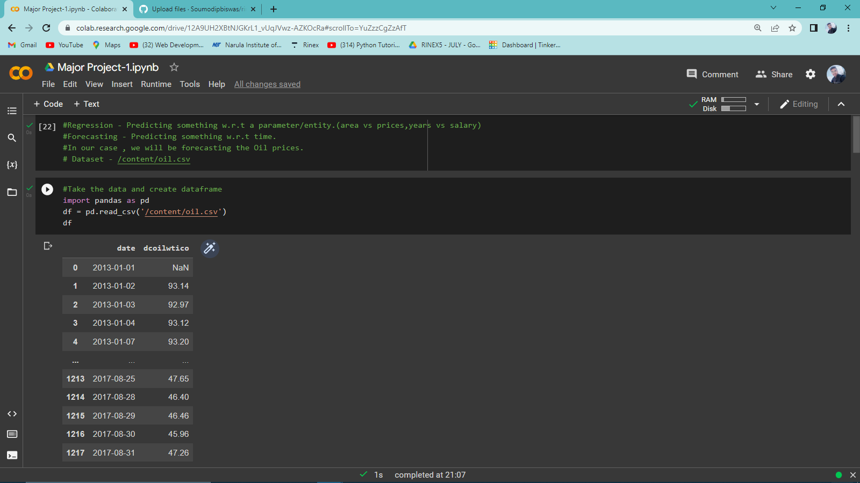

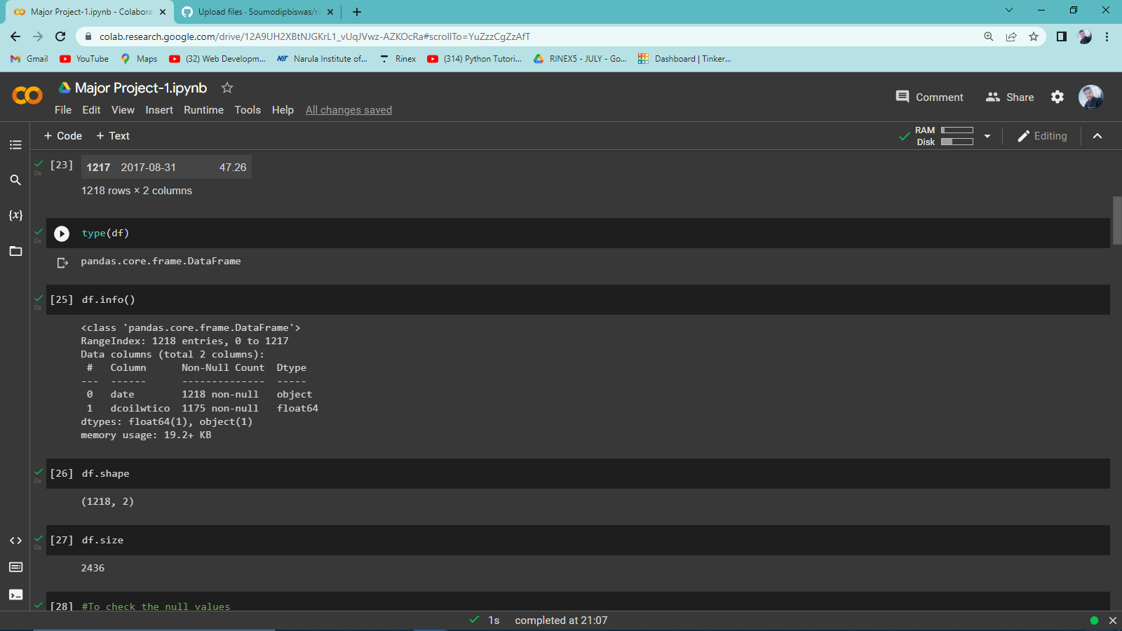

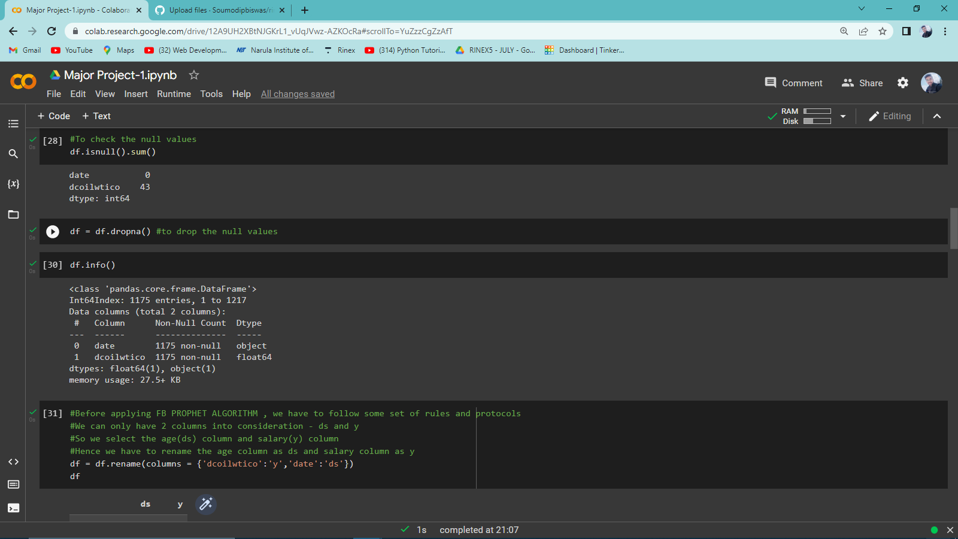

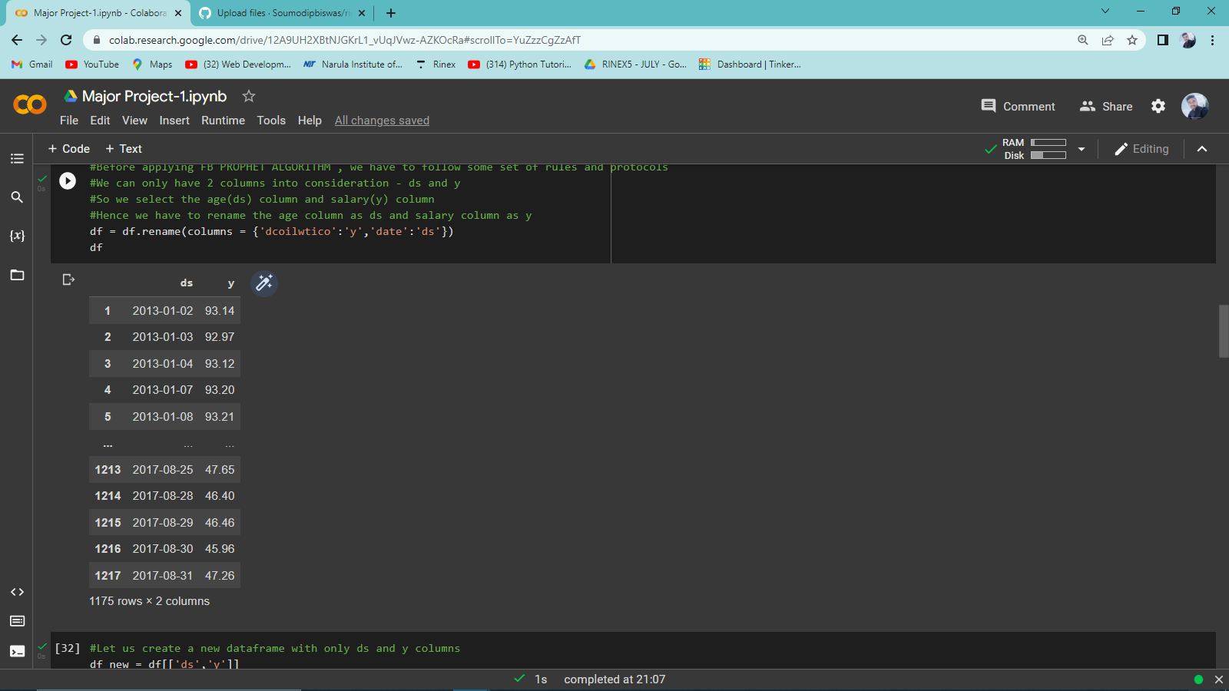

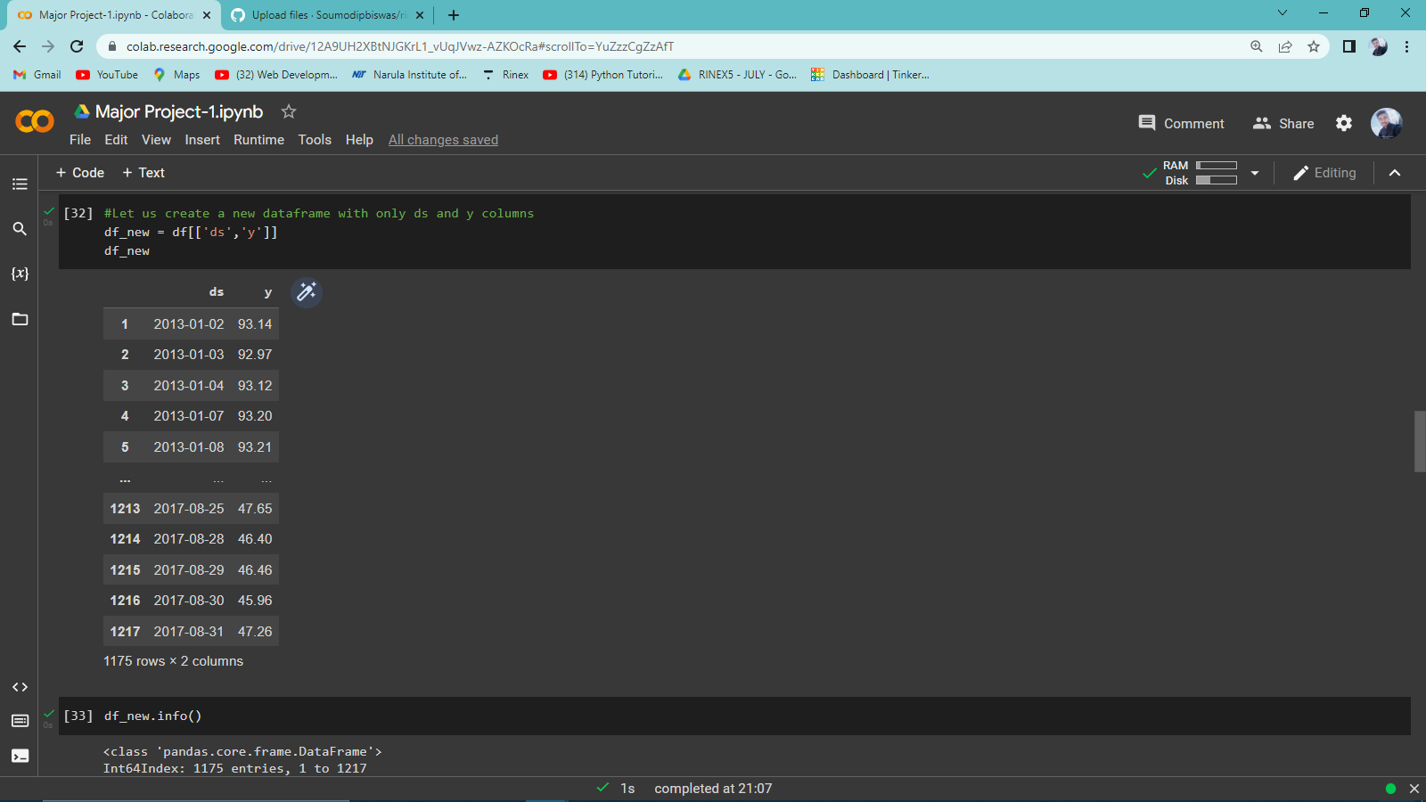

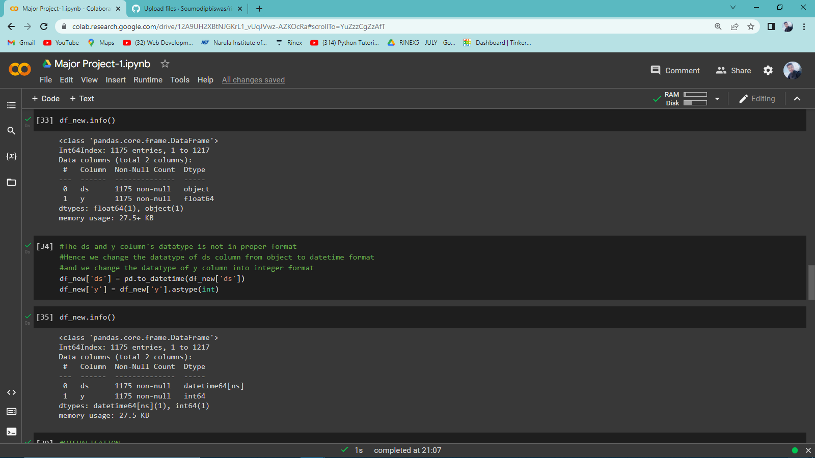

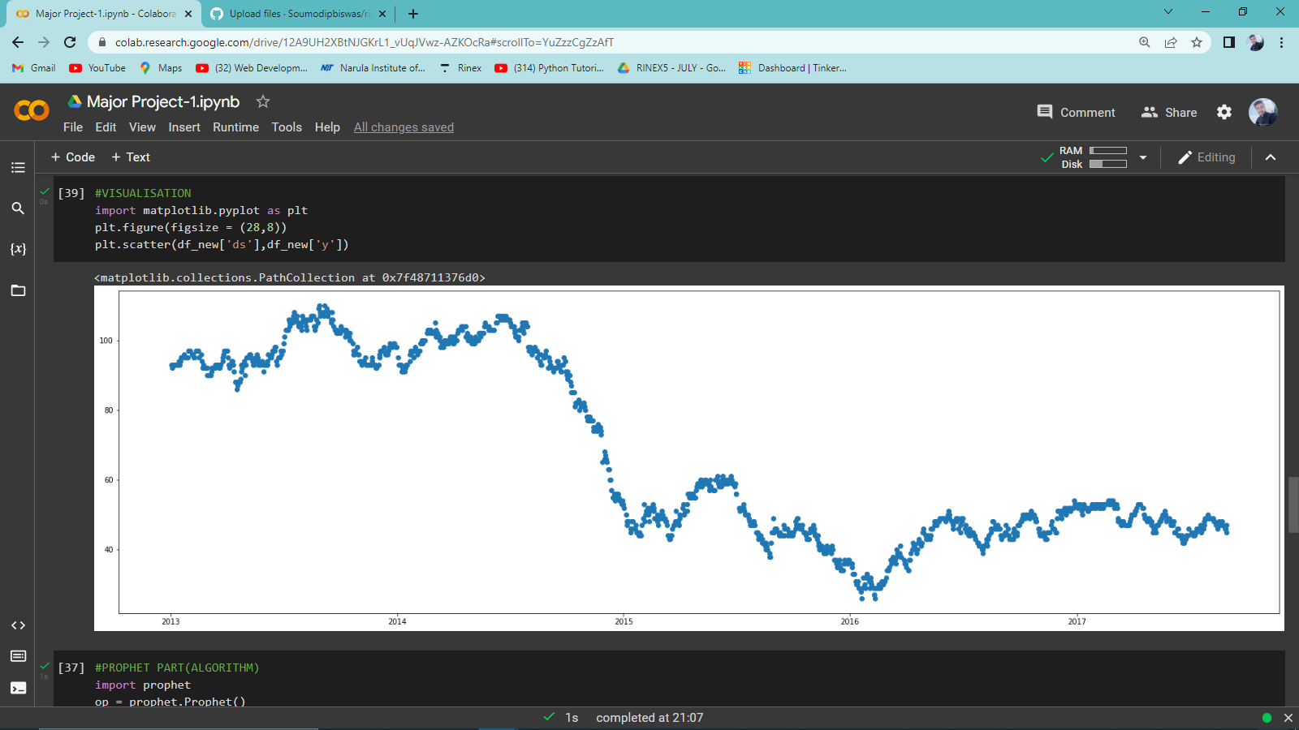

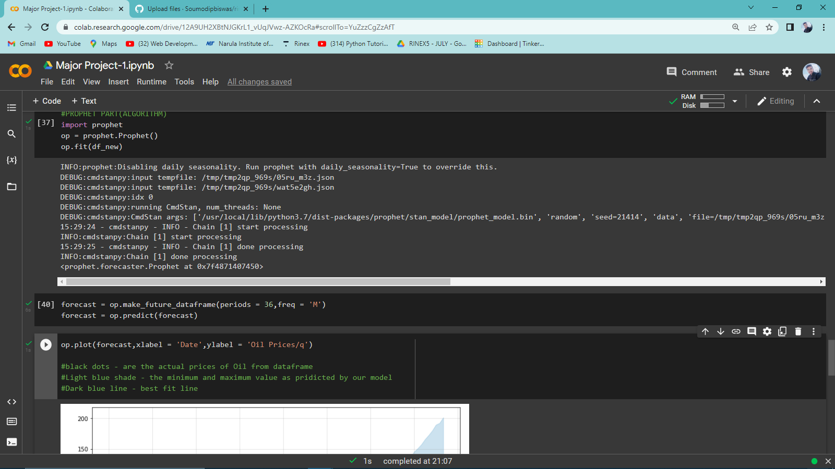

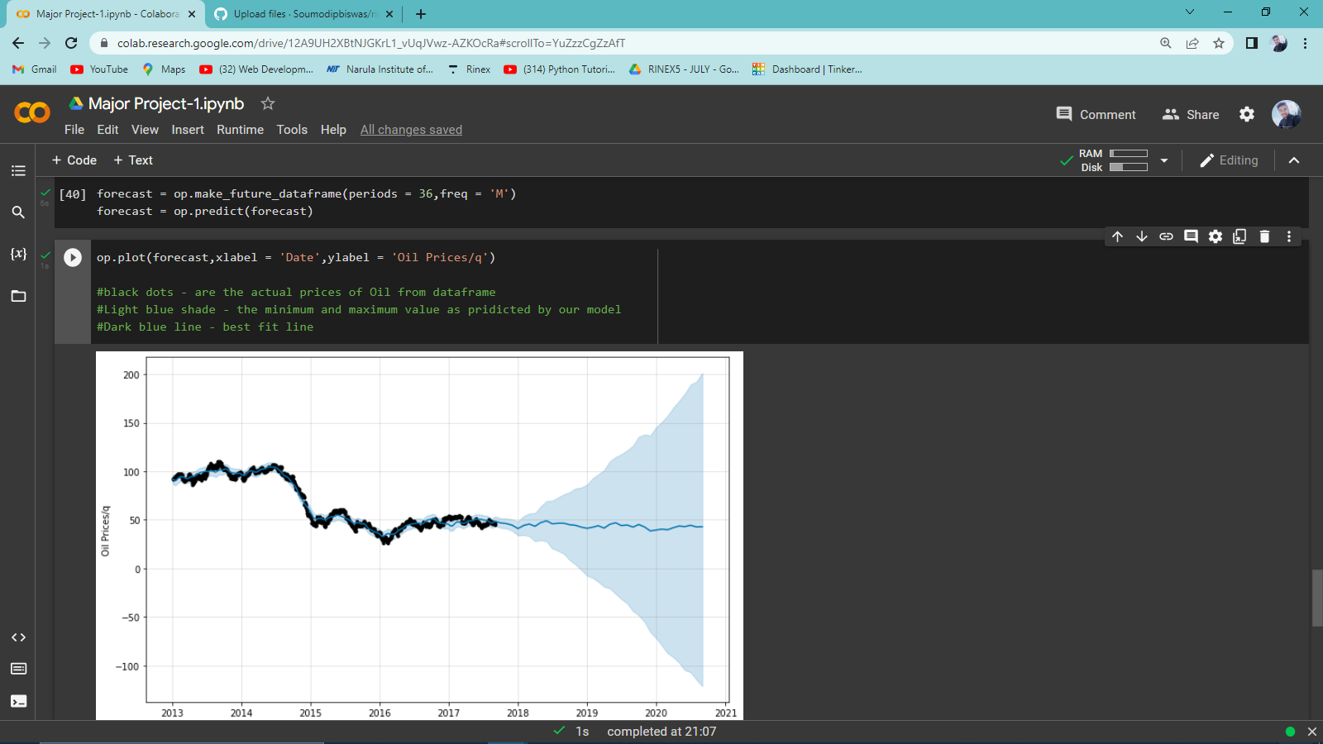

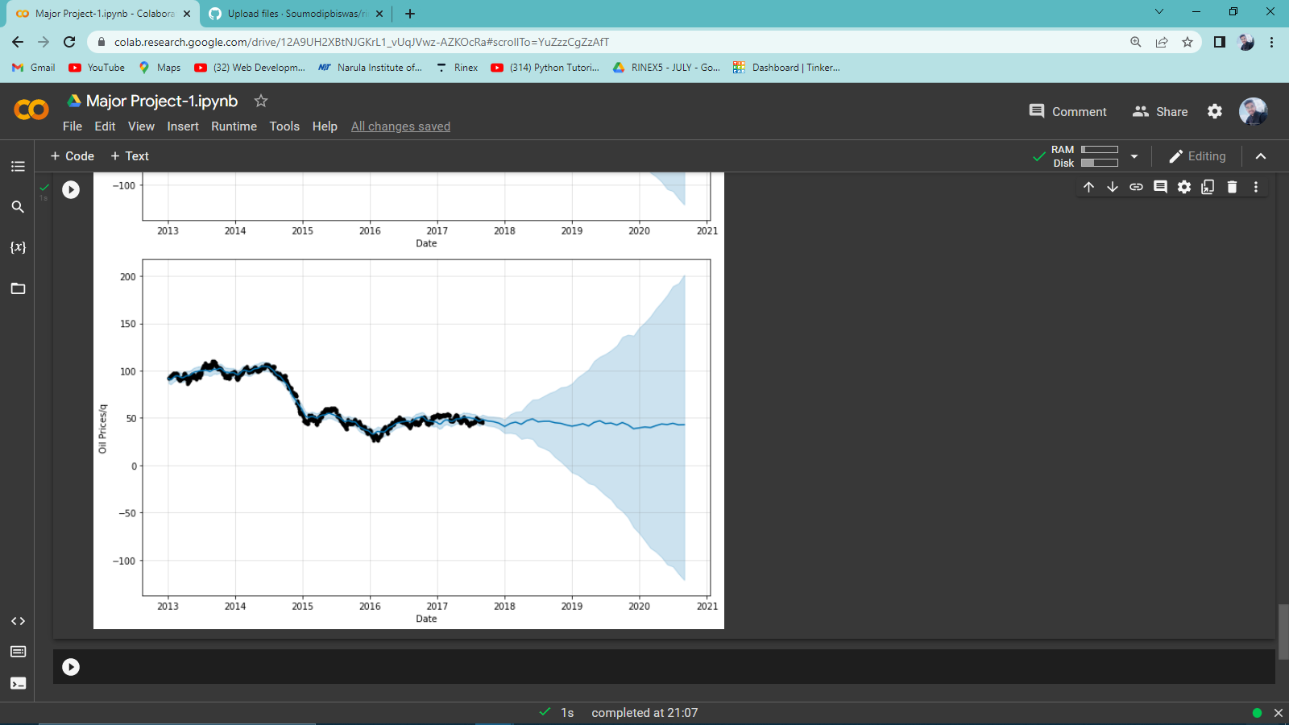

My GitHub account link:

<https://github.com/Soumodipbiswas>

rinex5 Repository link:

<https://github.com/Soumodipbiswas/rinex5>

Major Project – 2

Image processing using Numpy and OpenCV:

